**Step 1:** Selecting S3 from the storage of the AWS service panel

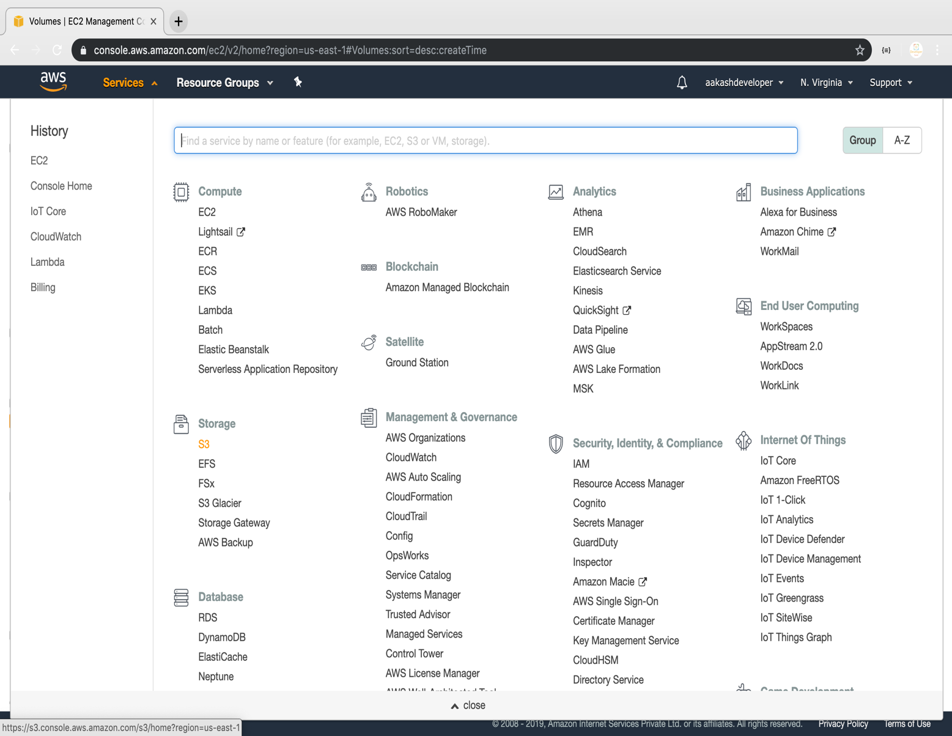

**Step 2:** Verifying the button to create a bucket

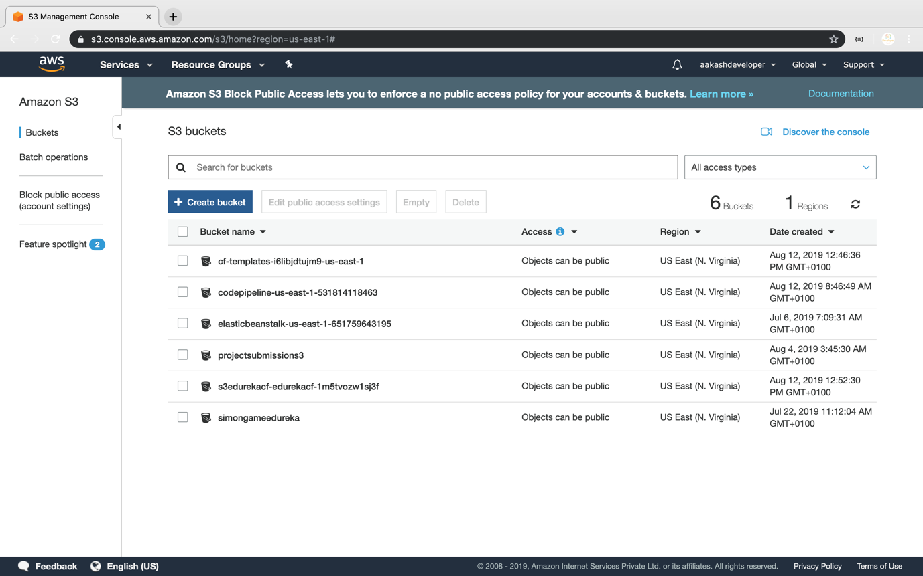

**Step 3:** Providing a bucket name and region

* Make sure that the bucket name is unique

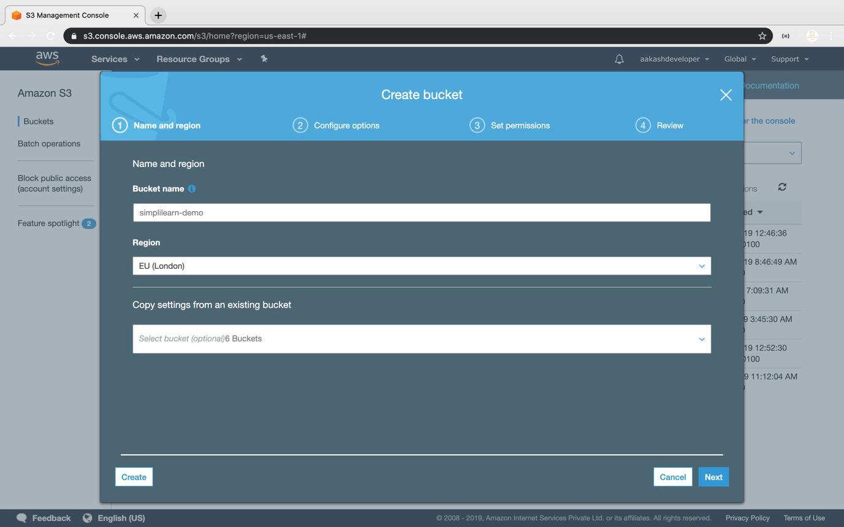

**Step 4:** Entering key and value for identification and tracking the bucket

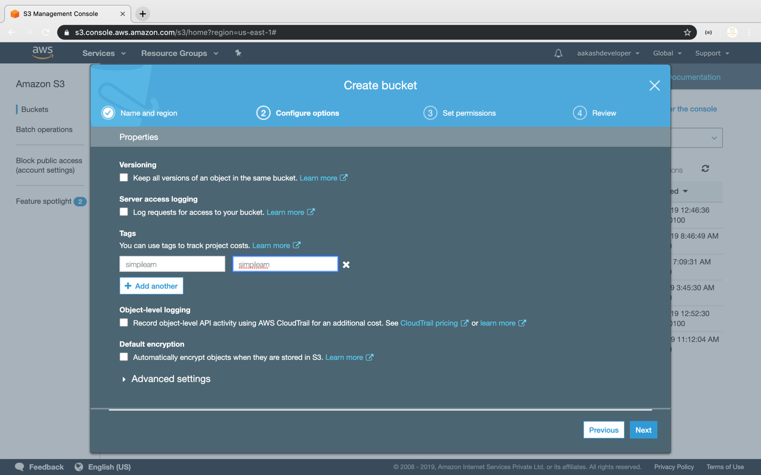

**Step 5:** Blocking all the public access

* If required, you can configure it later

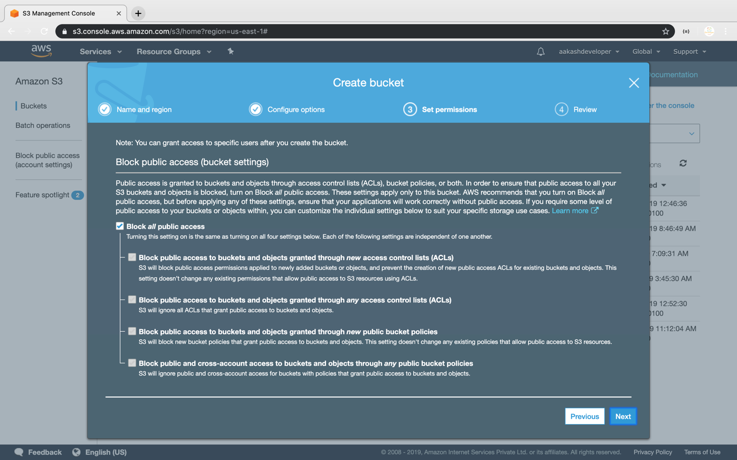

**Step 6:** Reviewing all parameters and creating the bucket

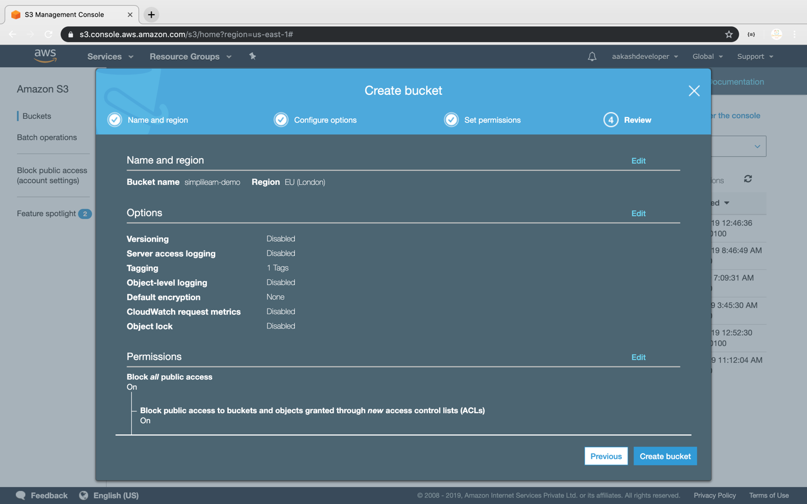

**Step 7:** Verifying the newly created bucket on the panel of S3

